THE ARCH OF THRIUMPH IN BUCHAREST
Arcul de Triumf is a triumphal arch located in the northern part of Bucharest, on the Kiseleff Road.
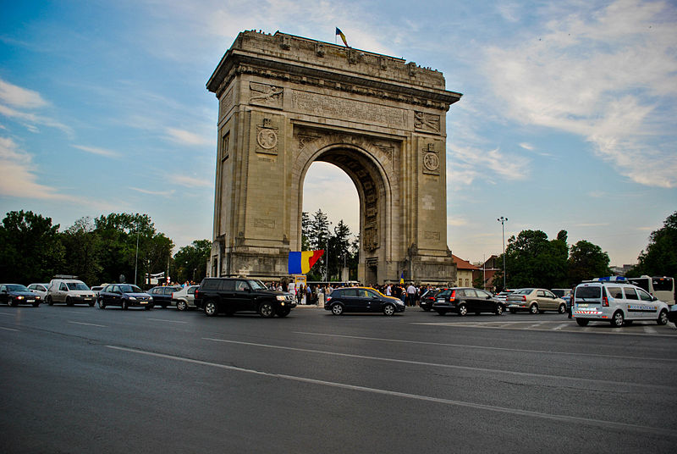
The first, wooden, triumphal arch was built hurriedly, after Romania gained its independence (1878), so that the victorious troops could march under it. Another temporary arch was built on the same site, in 1922, after World War I, which was demolished in 1935 to make way for the current triumphal arch, which was inaugurated in September 1936.
The current arch has a height of 27 metres and was built after the plans of the architect Petre Antonescu (architect) (ro). It has as its foundation a 25 x 11.50 metres rectangle. The sculptures with which the facades are decorated were created by famous Romanian sculptors such as Ion Jalea and Dimitrie Paciurea. Nowadays, military parades are held beneath the arch each 1 December, with the occasion of Romania's national holiday.

