Castle of the Teutonic Order in Malbork
This 13th-century fortified monastery belonging to the Teutonic Order was substantially enlarged and embellished after 1309, when the seat of the Grand Master moved here from Venice. A particularly fine example of a medieval brick castle, it later fell into decay, but was meticulously restored in the 19th and early 20th centuries. Many of the conservation techniques now accepted as standard were evolved here. Following severe damage in the Second World War it was once again restored, using the detailed documentation prepared by earlier conservators.

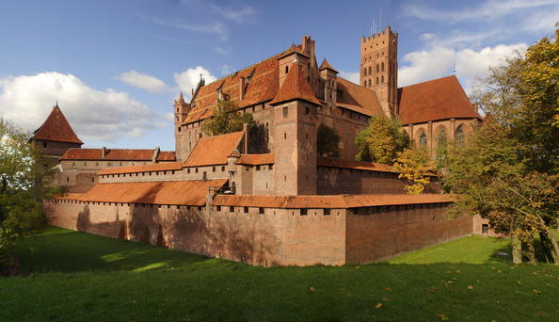
Malbork Castle is the most complete and elaborate example of the Gothic brick castle complex in the characteristic and unique style of the Teutonic Order, which evolved independently from the contemporary castles of western Europe and the Near East. The spectacular fortress represents the phenomenon of the monastic state in Prussia, founded in the 13th century and developed in the 14th century by the German communities of military monks who carried out crusades against the pagan Prussians on the south Baltic coast.
Since the 18th Century, the Malbork Castle has remained one of the major objects of European fascination with medieval history and its material remains.
After the first partition of Poland between Austria. Prussia, and Russia in 1772, Malbork Castle became part of the Kingdom of Prussia and was promptly modified to serve as a barracks; a number of unsympathetic demolitions and additions took place in the period 1799-1803. However, a number of artists and intellectuals had begun to take an interest in the Castle, and as a result of their pressure it was designated as an historic monument in 1804. Conservation work began after 1815 and continued until 1939.
The Castle was partly destroyed at the end of World War II, after which it passed once again within the boundaries of the new Poland. Since 1947 there have been continuous campaigns for the reconstruction and restoration of the monument.
