THE PALACE OF PARLIAMNET IN BUCHAREST
The Palace of Parliament (Romanian: Palatul Parlamentului) in Bucharest is a multi-purpose building.
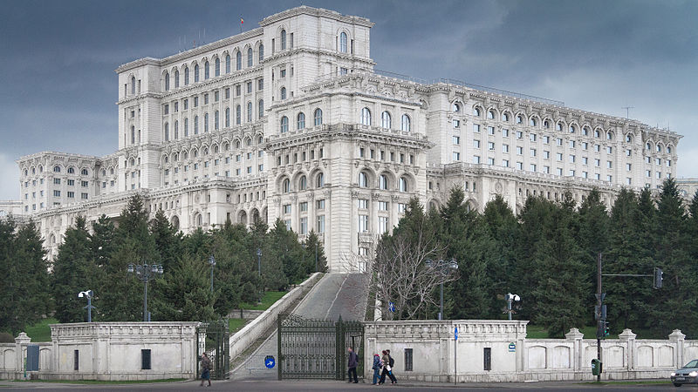
The Palace was designed by architect Anca Petrescu (chief architect who led a group of 700 architects⁾ and nearly completed by the Ceaușescu regime as the seat of political and administrative power. Nicolae Ceaușescu named it the People's House (Casa Poporului), also known in English as the Palace of the People.
Its construction started on 25 June 1984 and it was completed in 1997.
It cost €3 billion.
Its size: 270m by 240 m, 86 m high
92 m underground
1,100 rooms
12 stories tall
with four additional underground levels currently available and in use (another four in
different stages of completion.

