PELES CASTLE
Peleș Castle (Romanian: Castelul Peleș) is a Neo-Renaissance castle in the Carpathian Mountains, near Sinaia, in Prahova County, Romania. It is on an existing medieval route linking Transylvania and Wallachia and it was built between 1873 and 1914. Its inauguration was held in 1883.
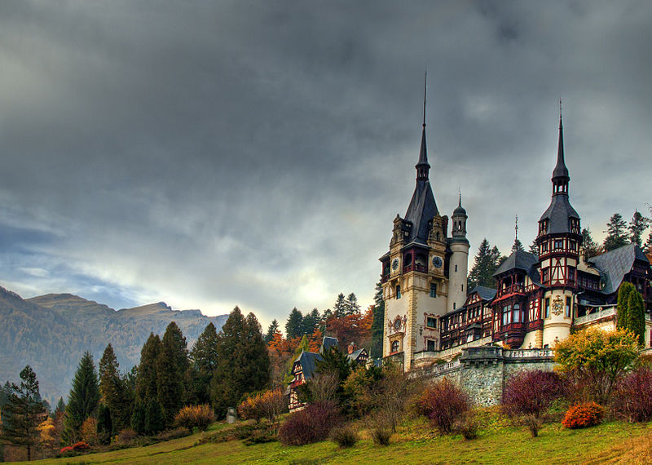
King Carol I of Romania (1839–1914), under whose reign the country gained its independence, first visited the site of the future castle in 1866 and fell in love with the magnificent mountain scenery. The estate was named the Royal Estate of Sinaia. The monarchy commissioned the construction of a royal hunting preserve and summer retreat on the property, and the foundation was laid for Peleș Castle on 22 August 1873.
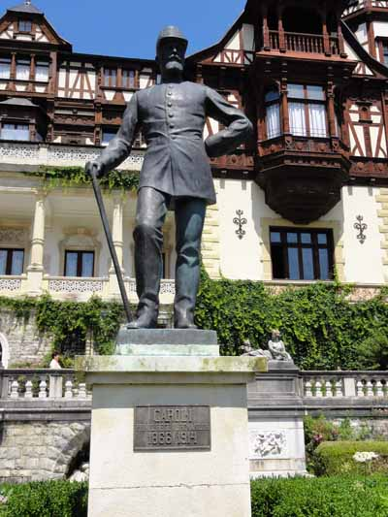
German architect Johannes Schultz (1876–1883) won the project by presenting a more original plan, something that appealed to the King's taste: a grand palatial alpine villa combining different features of classic European styles, mostly following Italian elegance and German aesthetics along Renaissance lines. Later additions were made between 1893 and 1914 by the Czech architect Karel Liman, who designed the towers, including the main central tower, which is 66 metres (217 ft) in height.
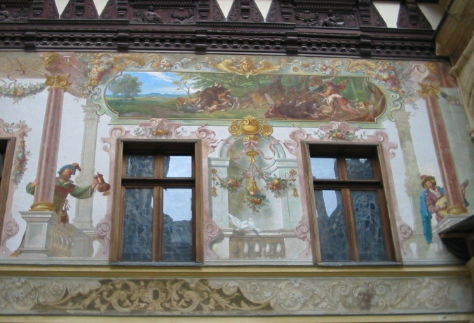
King Carol II was born at the castle in 1893, giving meaning to the phrase "cradle of the dynasty, cradle of the nation" that Carol I bestowed upon Peleș Castle.
After King Michael I's forced abdication in 1947, the Communist regime seized all royal property, including the Peleș Estate. The castle was opened as a tourist attraction for a short time.
Between 1975 and 1990 the area was declared a "State Protocol Interest Area".
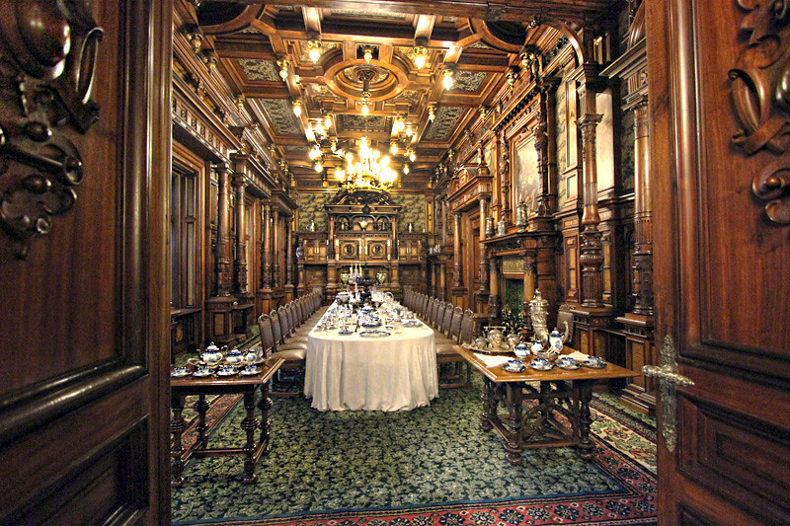
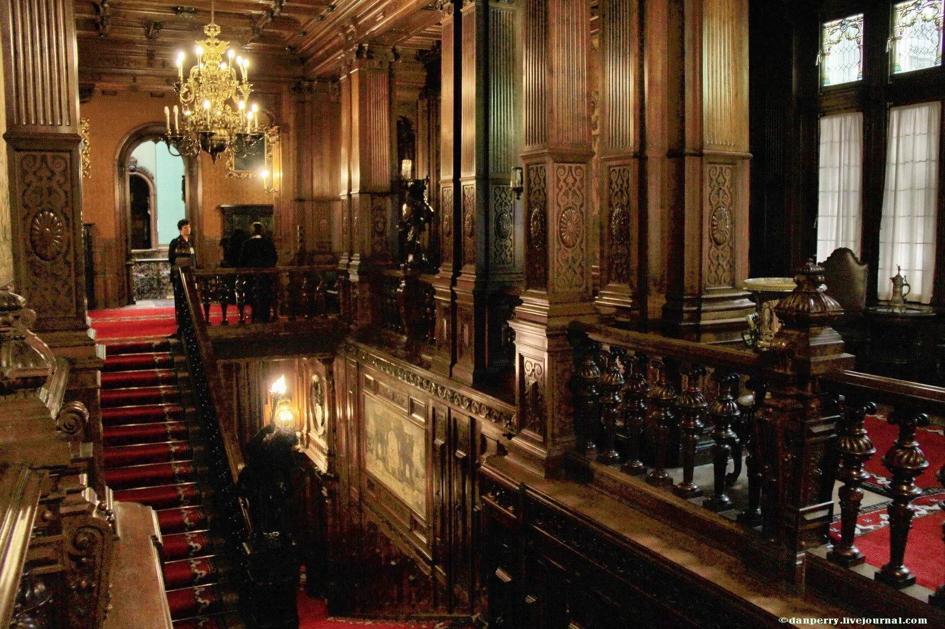
After the December 1989 Revolution, Peleş and Pelişor Castle were re-established as heritage sites and opened to the public.
Throughout its history, the castle hosted some important personalities, from royalty and politicians to artists. One of the most memorable visits was that of Kaiser Franz Joseph I of Austria-Hungary on 2 October 1896. Artists like George Enescu, Sarah Bernhardt, Jacques Thibaud and Vasile Alecsandri visited often as guests of Queen Elizabeth of Romania (herself a writer also known under the pen name of Carmen Sylva). In more recent times, many foreign dignitaries such as Richard Nixon, Gerald Ford, Muammar al-Gaddafi, and Yasser Arafat were welcomed at the castle.
The castle was featured in the 2009 film The Brothers Bloom. The exterior of the castle is used to represent a large estate in New Jersey, the home of an eccentric billionaire played by Rachel Weisz.

