Centennial Hall in Wroczlaw

The Centennial Hall (German: Jahrhunderthalle, Polish: Hala Stulecia (formerly Hala Ludowa - People's Hall)) is a historic building in Wrocław, Poland. It was constructed according to the plans of architect Max Berg in 1911–1913, when the city was part of the German Empire.
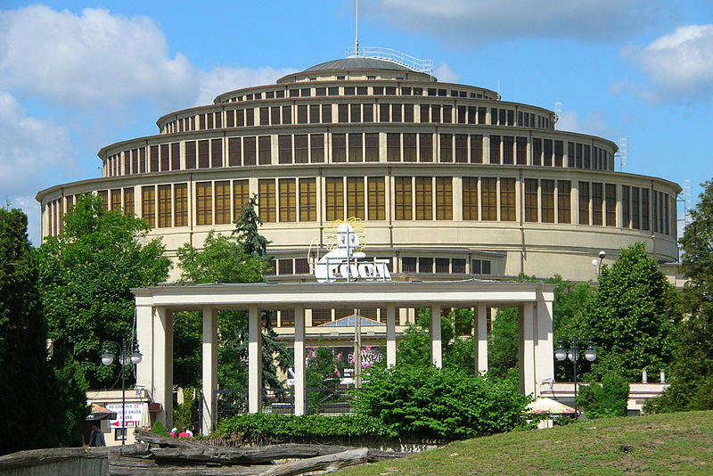
As an early landmark of reinforced concrete architecture, the building became one of Poland's official national Historic Monuments (Pomnik historii), as designated April 20, 2005, together with the Four Domes Pavilion, the Pergola, and the Iglica. Its listing is maintained by the National Heritage Board of Poland. It was also listed as a UNESCO World Heritage Site in 2006.
It was in the Silesian capital of Breslau on 10 March 1813 where King Frederick William III of Prussia called upon the Prussian and German people in his proclamation An Mein Volk to rise up against Napoleon's occupation. In October of that year, at the Battle of Leipzig, Napoleon was defeated.
The opening of the hall was part of the celebration commemorating the 100th anniversary of the battle, hence the name. Breslau's municipal authorities had vainly awaited state funding and ultimately had to defray the enormous costs out of their own pockets. The landscaping and buildings surrounding the hall were laid out by Hans Poelzig were opened on 20 May 1913 in the presence of Crown Prince William of Hohenzollern. The grounds include a huge pond with fountains enclosed by a huge concrete pergola in the form of half an ellipse. Beyond this, to the north, a Japanese garden was created. The Silesian author Gerhart Hauptmann had specially prepared a play Festspiel in deutschen Reimen, however the mise-en-scène by Max Reinhardt was suspended by national-conservative circles for its antimilitaristic tendencies.
After the memorial events, the building served as multi-purpose recreational building, situated in the Exhibition Grounds, previously used for horse racing. It was largely spared from the devastation by the Siege of Breslau and after the city had become part of the Republic of Poland according to the 1945 Potsdam Agreement, the hall was renamed Hala Ludowa ("People's Hall") by the communist government. In 1948, a 106 m (348 ft) high needle-like metal sculpture called Iglica was set up in front of it. The hall was extensively renovated in 1997 and in 2010. Recently the Polish translation of the original German name, Hala Stulecia, is official (but the manager^{[clarification needed]} is called Hala Ludowa).
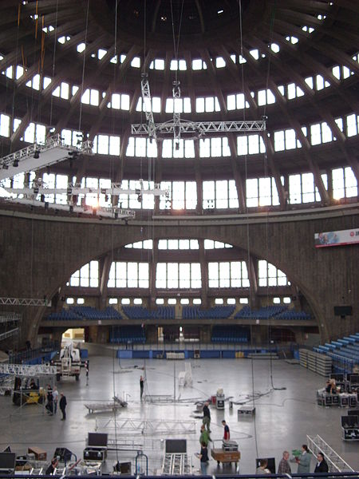
Centennial Hall hosted EuroBasket 1963 and a preliminary round group of the EuroBasket 2009 tournament.
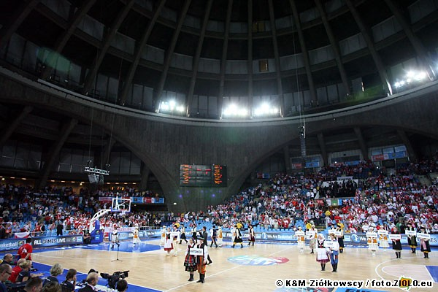
The hall continues to be in active use for sporting events and concerts.
After renovation in 2010 arena can hold 10 000 people.

