Bears’ Cave Museum

Bears Cave lies in the vicinity of the location called Chiscau, in Pietroasa Commune, Bihor District, at an altitude of 482 meters.
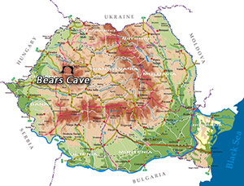
The name of the cave is due to the numerous bear fossils, which were found there, so therefore it represented a favorable place for shelter for the animals that used to live there 15000 years ago. Owing to the falling of a huge rock, the mouth of the cave was blocked and more than 140 bears were trapped inside. Being hungry, the bears attacked one another until they all died.
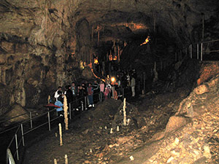
The cave was discovered in 1975 during the limestone exploitation works in the quarry from Chiscau. Until 17th September 1975 the cave was closed and in this time the subterranean pit was artificially opened through the dynamiting of the entrance gate.
The first man who went down the open pit was the miner Traian Curte from the same location. The way that he covered was from the access gallery to the Great Hall. At 20th September 1975, a group of amateur speleologists called “Speodora” accomplished the first exploitation of the cave and five years later the cave entered the touristic circuit of the country, being considered the first subterranean cavity arranged after the level of the world technique.
In this cave there are three galleries and four halls: The Candles Hall, The Spaghetti Hall, Emil Racovita Hall and The Bones Hall.
One may visit this cave starting from The Bears Gallery (called The Bones Gallery as well), where 1500 items, 140 skulls and numerous shelters for the cave bear can be seen. On the walls of the gallery, one may notice scratches left by the paws of the bears.
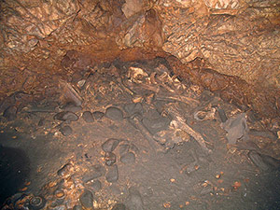
In the second gallery, called Emil Racovita, one may see a bear skeleton exposed just in the position the bear died and besides that, the fossils of other animals which disappeared hundreds of years ago: a black goat species, the cave lion and cave hyena. The distance between the walls of the cave is somewhere between 10-15 meters and its vault is at 10 meters height, being adorned with numerous stalagmites, domes, water basins and stalactites.
