Curtea de Arges Monastery

Curtea de Argeș Cathedral

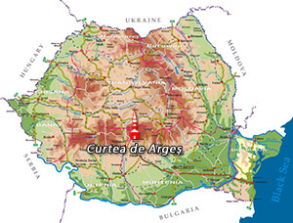

The Cathedral of Curtea de Argeș (early 16th century) is a Romanian Orthodox cathedral in Curtea de Arges, Romania. It is located on the grounds of the Curtea de Argeș Monastery, and it is dedicated to Saint Nicholas.

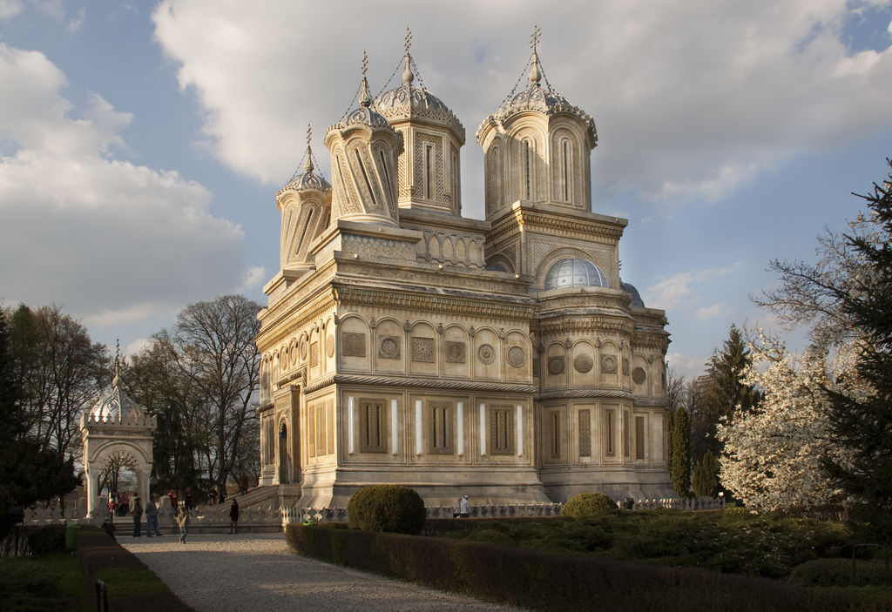

The building resembles a very large and elaborate mausoleum, and was built in the Byzantie style, with Moorish arabesques. A dome rises in the center, fronted by two smaller twisting and leaning cupolas, and there is a secondary dome, broader and loftier than the central one.

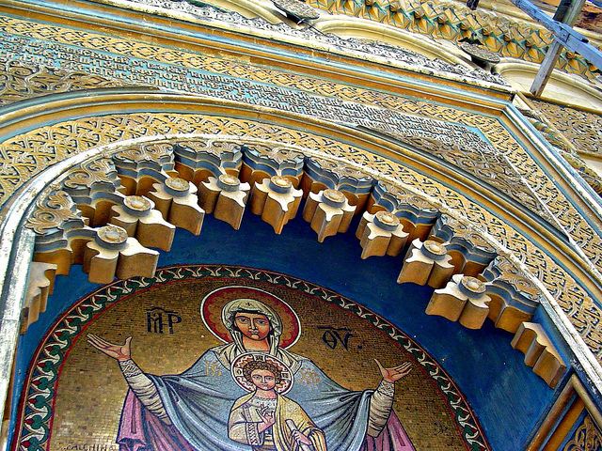

The archives of the cathedral were plundered by Hungarians and Turks, but several inscriptions, Greek, Slav, and Roman, are left.

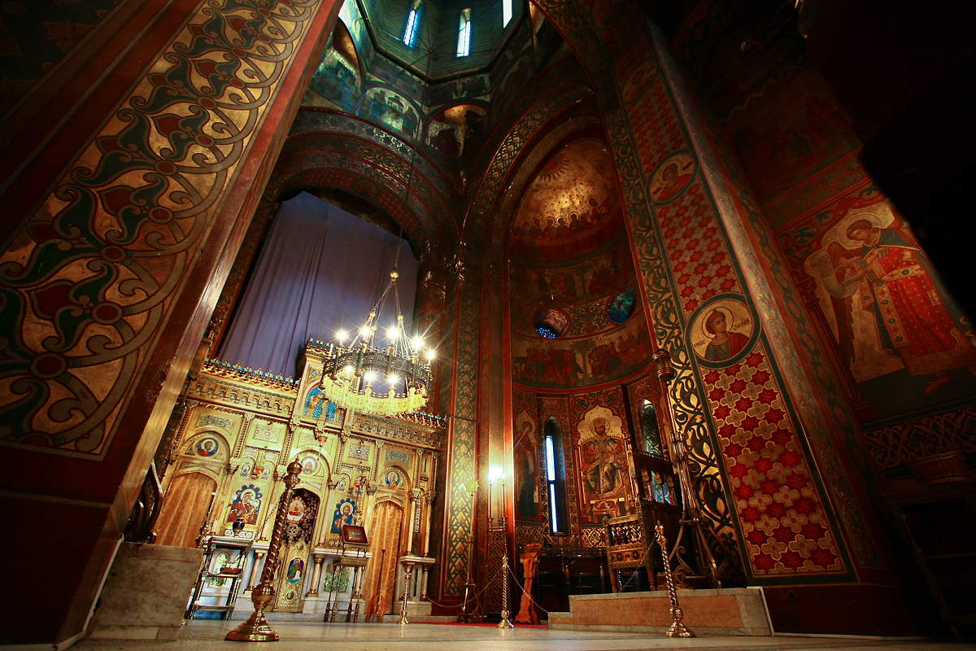

Legends

Legends of Curtea de Argeș have inspired many Romanian poets, among them the celebrated Vasile Alecsandri. One traditional legend describes how Neagoe Basarab, while a hostage in Constantinople, designed a splendid mosque for the sultan, returning to build the cathedral out of the surplus materials.
Manole legend
A legend tells of Radu Negru employing a Meșterul Manole or Manoli as architect. With Manole being unable to finish the walls, the prince threatened him and his assistants with death. At last Manole suggested that they should follow the ancient custom of placing a living woman into the foundations; and that she who first appeared on the following morning should be the victim. The other masons warned their families, and Manole was forced to sacrifice his own wife. Thus the cathedral was built.
When Manole and his masons told the prince that they could always build an even greater building, Radu Negru had them stranded on the roof so that they could not build something to match it. They fashioned wooden wings and tried to fly off the roof, but, one by one, they all fell to the ground. A spring of clear water, named after Manole, is said to mark the spot where he fell.

